# 实验二 基于Struts2的CRUD

一、实验目的：

熟悉Struts2 Action类的基本用法，掌握Struts2 Action类在MVC程序开发中的编写和应用，实现CRUD编程。

二、实验内容：

在MyEclipse环境下运用Struts2技术，完成数据库CRUD功能，调试运行程序。

三、实验要求：

1. 掌握运用Struts2 开发MVC程序的基本步骤；

2. 掌握Struts2 Action接收请求参数、调用业务逻辑、封装结果数据并转向结果页面的用法

3. 掌握在struts.xml文件中对Struts2 Action的基本配置；

4. 运用相关技术（Struts2以及JDBC等）完成规定功能；

5. 写出实验报告。

四、实验步骤：

1．进入MyEclipse环境，新建一个Web Project。

我这里用的是IDEA环境，新建Java Enterprise项目

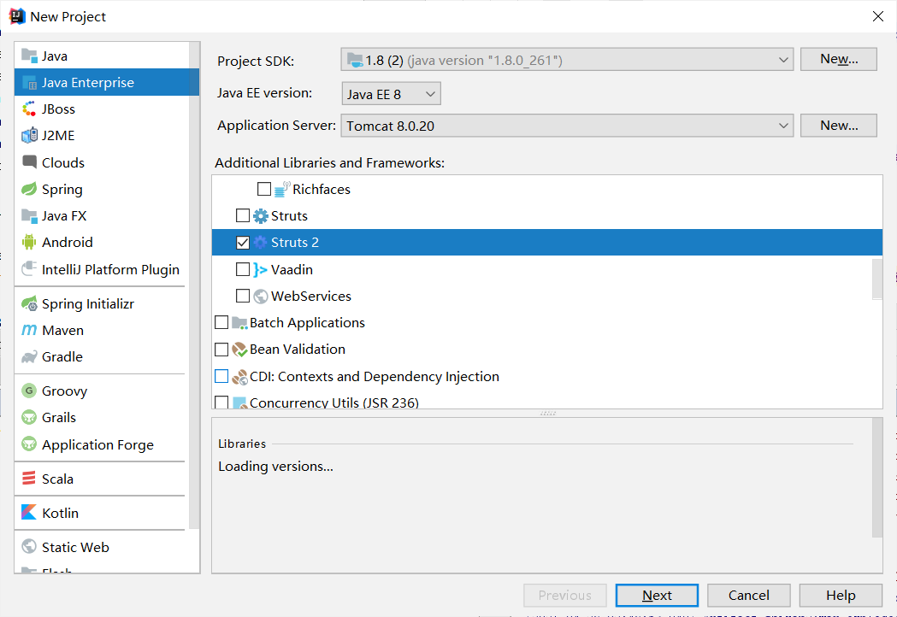

1. 设计数据库表结构。

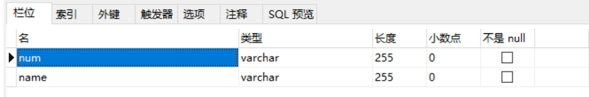

1. 采用Struts2技术完成数据库的CRUD。

添加jar包，解压



放到lib目录下

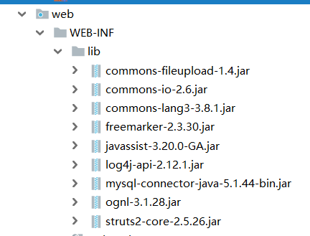

程序的目录

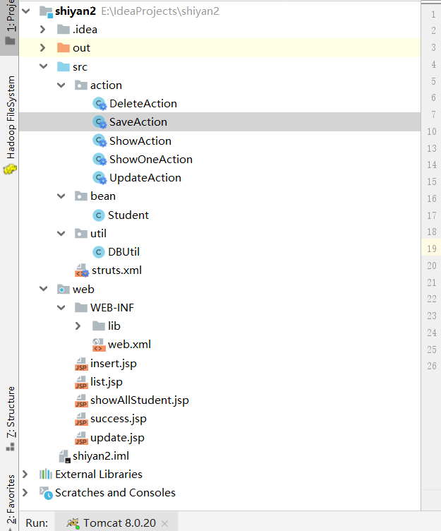

关键代码：

DBUtil

**package** util;  
**import** java.sql.*;  
**import** java.util.ArrayList;  
**import** java.util.List;  
  
**import** bean.Student;  
**public class** DBUtil {  
 Connection **conn**;  
 PreparedStatement **pstmt**;  
 String **url** = **"jdbc:mysql://localhost:3306/javaeeshiyan?useSSL=false&useUnicode=true&characterEncoding=UTF-8&zeroDateTimeBehavior=convertToNull&allowMultiQueries=true"**;  
 String **user** = **"root"**;  
 String **pwd** = **"123456"**;  
 **public** DBUtil(){  
 **try**{  
 Class.*forName*(**"com.mysql.jdbc.Driver"**);  
 **conn**=DriverManager.*getConnection*(**url**,**user**,**pwd**);  
 }**catch**(Exception e){  
 e.printStackTrace();  
 }  
 }  
 **public boolean** save(Student student){  
 **try**{  
 **pstmt**=**conn**.prepareStatement(**"insert into students values(?,?)"**);  
 **pstmt**.setString(1, student.getNum());  
 **pstmt**.setString(2, student.getName());  
 **pstmt**.executeUpdate();  
 **return true**;  
 }**catch**(Exception e){  
 e.printStackTrace();  
 **return false**;  
 }  
 }  
 **public** List<Student> showStudent() **throws** SQLException, ClassNotFoundException{  
 ResultSet rs = **null**;  
 List<Student> list = **new** ArrayList<Student>();  
 String sql = **"select** *\** **from students"**;  
 **try** {  
 **pstmt** = **conn**.prepareStatement(sql);  
 rs = **pstmt**.executeQuery();  
 **while**(rs.next()) {  
 Student student = **new** Student();  
 student.setNum(rs.getString(**"num"**));  
 student.setName(rs.getString(**"name"**));  
 list.add(student);  
 }  
 **conn**.close();  
 rs.close();  
 **pstmt**.close();  
  
 } **catch** (SQLException e) {  
 *//* ***TODO Auto-generated catch block*** e.printStackTrace();  
 }  
 **return** list;  
 }  
  
 **public** Student showOneStudent(String num) {  
 ResultSet rs = **null**;  
 String sql = **"select** *\** **from students where num="** + num;  
 Student student = **new** Student();  
 **try** {  
 **pstmt** = **conn**.prepareStatement(sql);  
 rs = **pstmt**.executeQuery();  
 **while** (rs.next()) {  
 student.setNum(rs.getString(**"num"**));  
 student.setName(rs.getString(**"name"**));  
 }  
 } **catch** (Exception e) {  
 e.printStackTrace();  
 } **finally** {  
 **try** {  
 **pstmt**.close();  
 } **catch** (SQLException e) {  
 e.printStackTrace();  
 }  
 **try** {  
 **conn**.close();  
 } **catch** (SQLException e) {  
 e.printStackTrace();  
 }  
 }  
 **return** student;  
 }  
  
 */*  
 * 删除一个学生  
 */* **public void** deleteStudent(String num) {  
 String sql = **"delete from students where num="** + num;  
 System.***out***.println(num + **"::::num"**);  
 **try** {  
 **pstmt** = **conn**.prepareStatement(sql);  
 **pstmt**.execute();  
 } **catch** (Exception e) {  
 e.printStackTrace();  
 } **finally** {  
 **try** {  
 **pstmt**.close();  
 } **catch** (SQLException e) {  
 e.printStackTrace();  
 }  
 **try** {  
 **conn**.close();  
 } **catch** (SQLException e) {  
 e.printStackTrace();  
 }  
 }  
 }  
 */*  
 * 更新一个学生的信息  
 */* **public** Student updateSaveStudent(Student student) {  
 String sql = **"update students set name=? where num="** + student.getNum();  
 **try** {  
 **pstmt** = **conn**.prepareStatement(sql);  
 **pstmt**.setString(1, student.getName());  
 **pstmt**.execute();  
 } **catch** (Exception e) {  
 e.printStackTrace();  
 } **finally** {  
 **try** {  
 **pstmt**.close();  
 } **catch** (SQLException e) {  
 e.printStackTrace();  
 }  
 **try** {  
 **conn**.close();  
 } **catch** (SQLException e) {  
 e.printStackTrace();  
 }  
 }  
 **return** student;  
 }  
}

Student

**package** bean;  
**public class** Student {  
 **private** String **num**;  
 **private** String **name**;  
  
 **public** Student() {  
 **super**();  
 *//* ***TODO Auto-generated constructor stub*** }  
  
 **public** Student( String name, String num) {  
 **super**();  
 **this**.**num** = num;  
 **this**.**name** = name;  
 }  
 **public** String getNum() {  
 **return num**;  
 }  
  
 **public void** setNum(String num) {  
 **this**.**num** = num;  
 }  
  
 **public** String getName() {  
 **return name**;  
 }  
  
 **public void** setName(String name) {  
 **this**.**name** = name;  
 }  
  
}

DeleteAction

**package** action;  
**import** bean.Student;  
**import** com.opensymphony.xwork2.ActionSupport;  
**import** util.DBUtil;  
**public class** DeleteAction **extends** ActionSupport{  
 **private** Student **student**;  
 **public** Student getStudent() {  
 **return student**;  
 }  
 **public void** setStudent(Student student) {  
 **this**.**student**=student;  
 }  
 **public** String execute() **throws** Exception {  
 Student student1 = **new** Student();  
 DBUtil db = **new** DBUtil();  
 db.deleteStudent(**student**.getNum());  
 System.***out***.println(**"学号为"**+**student**.getNum() + **"的学生信息已经被删除！"**);  
 **return *SUCCESS***;  
 }  
}

SaveAction

**package** action;  
**import** bean.Student;  
**import** util.DBUtil;  
**import** com.opensymphony.xwork2.ActionSupport;  
**public class** SaveAction **extends** ActionSupport {  
 **private** Student **student**;  
 **public** Student getStudent() {  
 **return student**;  
 }  
 **public void** setStudent(Student student) {  
 **this**.**student**=student;  
 }  
 **public** String execute() **throws** Exception{  
 DBUtil db=**new** DBUtil();  
 Student stu=**new** Student();  
 stu.setNum(**student**.getNum());  
 stu.setName(**student**.getName());  
 **if**(db.save(stu)){  
 **return *SUCCESS***;  
 }**else**{  
 **return *ERROR***;  
 }  
 }  
  
}

ShowAction

**package** action;  
**import** bean.Student;  
**import** com.opensymphony.xwork2.ActionContext;  
**import** com.opensymphony.xwork2.ActionSupport;  
**import** util.DBUtil;  
**import** java.sql.SQLException;  
**import** java.util.ArrayList;  
**import** java.util.List;  
**import** java.util.Map;  
**public class** ShowAction **extends** ActionSupport {  
 **private** Student **student**;  
 **public** Student getStudent() {  
 **return student**;  
 }  
 **public void** setStudent(Student student) {  
 **this**.**student**=student;  
 }  
 **public** String execute() **throws** Exception{  
 DBUtil db=**new** DBUtil();  
 List<Student> studentList = **new** ArrayList<Student>();  
 **try** {  
 studentList = db.showStudent();  
 } **catch** (SQLException e) {  
 e.printStackTrace();  
 }  
 Map request = (Map) ActionContext.*getContext*().get(**"request"**);  
 request.put(**"studentList"**, studentList);  
 **return *SUCCESS***;  
  
 }  
}

ShowOneAction

**package** action;  
**import** bean.Student;  
**import** com.opensymphony.xwork2.ActionContext;  
**import** com.opensymphony.xwork2.ActionSupport;  
**import** util.DBUtil;  
**import** java.sql.SQLException;  
**import** java.util.ArrayList;  
**import** java.util.List;  
**import** java.util.Map;  
**public class** ShowOneAction **extends** ActionSupport {  
 **private** Student **student**;  
 **public** Student getStudent() {  
 **return student**;  
 }  
 **public void** setStudent(Student student) {  
 **this**.**student**=student;  
 }  
 */*  
 * 查询一个学生信息  
 */* **public** String execute() **throws** Exception{  
 Student student1=**new** Student();  
 DBUtil db=**new** DBUtil();  
 student1=db.showOneStudent(**student**.getNum());*//查询一个学生信息* Map request=(Map) ActionContext.*getContext*().get(**"request"**);  
 request.put(**"student1"**, student1);*//将查询的学生信息放到Map容器中* **return *SUCCESS***;  
 }  
}

UpdateAction

**package** action;  
**import** bean.Student;  
**import** com.opensymphony.xwork2.ActionContext;  
**import** com.opensymphony.xwork2.ActionSupport;  
**import** util.DBUtil;  
**import** java.sql.SQLException;  
**import** java.util.ArrayList;  
**import** java.util.List;  
**import** java.util.Map;  
**public class** UpdateAction **extends** ActionSupport {  
 **private** Student **student**;  
  
 **public** Student getStudent() {  
 **return student**;  
 }  
  
 **public void** setStudent(Student student) {  
 **this**.**student**=student;  
 }  
 **public** String execute() **throws** Exception {  
 DBUtil db = **new** DBUtil();  
 **student**.setNum(**student**.getNum());  
 **student**.setName(**student**.getName());  
 db.updateSaveStudent(**student**);  
 **return *SUCCESS***;  
 }  
}

Web.xml

*<?***xml version="1.0" encoding="UTF-8"***?>*<**web-app xmlns="http://xmlns.jcp.org/xml/ns/javaee"  
 xmlns:xsi="http://www.w3.org/2001/XMLSchema-instance"  
 xsi:schemaLocation="http://xmlns.jcp.org/xml/ns/javaee http://xmlns.jcp.org/xml/ns/javaee/web-app_3_1.xsd"  
 version="3.1"**>  
  
 <**display-name**>BasicSrtuts2</**display-name**>  
 <**welcome-file-list**>  
 <**welcome-file**>showAllStudent.jsp</**welcome-file**>  
 </**welcome-file-list**>  
  
 <**filter**>  
 <**filter-name**>struts2</**filter-name**>  
 <**filter-class**>org.apache.struts2.dispatcher.filter.StrutsPrepareAndExecuteFilter</**filter-class**>  
 </**filter**>  
 <**filter-mapping**>  
 <**filter-name**>struts2</**filter-name**>  
 <**url-pattern**>/*</**url-pattern**>  
 </**filter-mapping**>  
</**web-app**>

Struts.xml

*<?***xml version="1.0" encoding="UTF-8"***?>***<!DOCTYPE struts PUBLIC  
 "-//Apache Software Foundation//DTD Struts Configuration 2.0//EN"  
 "http://struts.apache.org/dtds/struts-2.0.dtd"*>***<**struts**>  
 <**constant name="struts.devMode" value="true"**/>  
 <**package name="basicstruts2" extends="struts-default"**>  
  
 <**action name="save" class="action.SaveAction"**>  
 <**result name="success"**>/success.jsp</**result**>  
 <**result name="error"**>/insert.jsp</**result**>  
 </**action**>  
 *<!--查询所有学生 -->* <**action name="showAllStudent" class="action.ShowAction" method="execute"**>  
 <**result name="success"**>/list.jsp</**result**>  
 <**result name="error"**>/insert.jsp</**result**>  
 <**result name="input"**>/insert.jsp</**result**>  
 </**action**>  
 *<!-- 删除学生 -->* <**action name="deleteStudent" class="action.DeleteAction" method="execute"**>  
 <**result name="success"**>/showAllStudent.jsp</**result**>  
 <**result name="error"**>/showAllStudent.jsp</**result**>  
 <**result name="input"**>/showAllStudent.jsp</**result**>  
 </**action**>  
 *<!-- 查询要更新的学生信息 -->* <**action name="updateStudent" class="action.ShowOneAction" method="execute"**>  
 <**result name="success"**>/update.jsp</**result**>  
 <**result name="error"**>/showAllStudent.jsp</**result**>  
 <**result name="input"**>/showAllStudent.jsp</**result**>  
 </**action**>  
 *<!-- 更新学生信息 -->* <**action name="updateSaveStudent" class="action.UpdateAction" method="execute"**>  
 <**result name="success"**>/showAllStudent.jsp</**result**>  
 <**result name="error"**>/showAllStudent.jsp</**result**>  
 <**result name="input"**>/showAllStudent.jsp</**result**>  
 </**action**>  
 </**package**>  
</**struts**>

Insert.jsp

<%@ **page contentType**="**text/html;charset=UTF-8**" **language**="**java**" %>  
<%@ **taglib uri**="**/struts-tags**" **prefix**="**s**"%>  
<**html**>  
<**head**>  
 <**title**>添加学生</**title**>  
</**head**>  
<**body**>  
<**center**>  
<**h2**>添加学生</**h2**>  
<**s:form action="save" method="post" theme="simple"**>  
 学号：<**s:textfield name="student.num"**></**s:textfield**><**br**>  
姓名：<**s:textfield name="student.name"**></**s:textfield**><**br**>  
 <**s:submit value="添加"**></**s:submit**>  
</**s:form**>  
 <**a href="showAllStudent.jsp"**>返回</**a**>  
</**center**>  
</**body**>  
</**html**>

List.jsp

<%@ **page language**="**java**" **pageEncoding**="**utf-8**"%>  
<%@ **taglib uri**="**/struts-tags**" **prefix**="**s**"%>  
<**html**>  
<**body** >  
<**center**>  
<**h2**>学生信息情况</**h2**>  
<**hr**>  
<**a href="insert.jsp"**>添加学生</**a**>  
<**table border="1"**>  
 <**tr align="center"**>  
 <**td**>学号</**td**>  
 <**td**>姓名</**td**>  
 <**td colspan ="2"**>操作</**td**>  
 </**tr**>  
 <**s:iterator value="#request.studentList" var="list"**>  
 <**tr**>  
 <**td**><**s:property value="#list.num"**/></**td**>  
 <**td**><**s:property value="#list.name"**/></**td**>  
  
 <**td**>  
 <**a href="deleteStudent.action?student.num=**<**s:property value="#list.num"**/>**" onClick="if**(!*confirm*(**'确定删除该信息吗？'**))**return false**;**else return true**;**"**>删除</**a**>  
 </**td**>  
 <**td**>  
 <**a href="updateStudent.action?student.num=**<**s:property value="#list.num"**/>**"**>修改</**a**>  
 </**td**>  
 </**tr**>  
 </**s:iterator**>  
</**table**>  
<**p**>  
</**center**>  
</**body**>  
</**html**>

ShowAllStudent.jsp

<%@ **page language**="**java**" **contentType**="**text/html;charset=utf-8**" **pageEncoding**="**utf-8**"%>  
<%@ **taglib prefix**="**s**" **uri**="**/struts-tags**" %>  
<**html**>  
<**body**>  
<**s:action name="showAllStudent" executeResult="true"**/>  
</**body**>  
</**html**>

Success.jsp

<%@ **page contentType**="**text/html;charset=UTF-8**" **language**="**java**" %>  
<**html**>  
<**head**><**title**>success</**title**>  
</**head**>  
  
<**body**>  
<**center**>  
恭喜你，成功添加！  
</**center**>  
</**body**>  
</**html**>

Update.jsp

<%@ **page language**="**java**" **pageEncoding**="**utf-8**"%>  
<%@ **taglib uri**="**/struts-tags**" **prefix**="**s**"%>  
<**html**>  
<**center**>  
 <**h3**>该学生信息</**h3**>  
 <**hr**>  
 <**s:set value="#request.student1" var="onestu"**></**s:set**>  
 <**form action="updateSaveStudent.action" method="post" enctype="multipart/form-data"** >  
 <**table border="1" width="400"**>  
 <**tr**>  
 <**td**>学号：</**td**>  
 <**td**>  
 <**input type="text" name="student.num" value="**<**s:property value="#onestu.num"**/>**" readonly**/>  
 </**td**>  
 </**tr**>  
 <**tr**>  
 <**td**>姓名：</**td**>  
 <**td**>  
 <**input type="text" name="student.name" value="**<**s:property value="#onestu.name"**/>**"**/>  
 </**td**>  
 </**tr**>  
 </**table**>  
 <**p**>  
 <**input type="submit" value="修改"**/>  
 <**input type="button" value="返回" onclick="javascript**:***history***.back();**"**/>  
 </**form**>  
</**center**>  
</**body**>  
</**html**>

1. 程序运行截图。

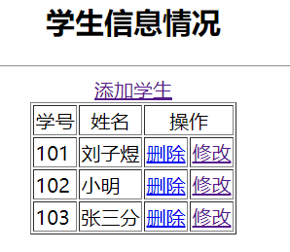

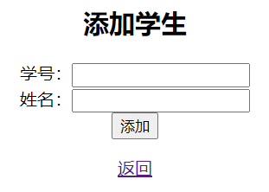

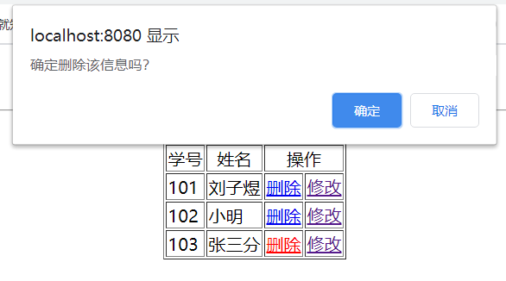

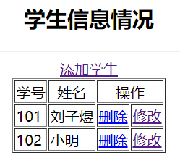

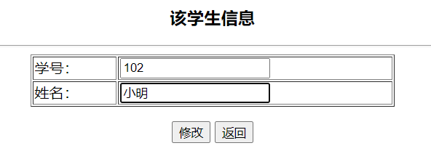

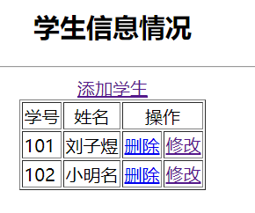

五、心得体会：

学习了Struts2框架，虽然听说现在很少人用这个了，但是还是有可以学习的地方，掌握了Struts2 Action接收请求参数、调用业务逻辑、封装结果数据并转向结果页面的用法，了解了在struts.xml文件如何配置。